

**Age and Gender Detection**

Ajit Barman

Siliguri Institute of Thechnology, Darjeeling

West Bengal - India

**ABSTRACT**

The detection is the technique in which various factors are recognized on the basis of input and according to requirements. The age and gender detection is the issue which take consideration of researchers from last few years. In the topic on age and gender detection various techniques has been proposed to analysis features of the input image and on the basis of image features gender and approximation of age is defined. In this work, novel technique is proposed which is based on SIFT and morphological algorithm for age and gender detection. The morphological technique scan the input image and SIFT algorithm detect key features. The simulation is performed in MATLAB and it is been analyzed that proposed technique performs well in terms of fault detection rate and accuracy

***Keywords:-*** Detection, SIFT, Morphological, key features

**I. INTRODUCTION**

The enhancing of raw images that are received from the camera sources, from satellites, aircrafts and the pictures captured in day-to-day lives is called image processing. The images have been processed through many different techniques and calculations have been made on the basis and analysis of the studies. There is a need of analyzing and studying the digitally formed images. There are two main and very common steps followed for image processing. The improvement of an image such that the resulted image is of greater quality and can be used by other programs, is called image enhancement [1]. The other technique is the most sought after technique used for extraction of information from an image. There is a division of the image into certain number of parts or objects so that the problem is solved. This process is called segmentation.

A neural network consists of many simple and similar compressing elements. It is a system with inputs and outputs. There are a number of internal parameters called weights. An artificial neural network is made of set of processing elements which are also known as neurons or nodes [2]. These nodes are interconnected. Training in ANN is done through the track of the examples. There are various such methods that fail to produce appropriate results. For each class, an essential rule called the characteristic rule is generated. This set of rules is also called as differentiating rules. A systematic method which is used to train multilayer artificial neural networks is known as back propagation. It is also considered as a gradient method where the gradient of the error is evaluated by considering the weights of the given inputs [3].

The detection of the data available in the images is very important. The data that the image contains is to be changed and modified for the detection purposes. There are various types of techniques involved for detection as well as the removal of the problem. In a Facial detection technique: The expressions that the faces contain hold a lot of information. Whenever a person interacts with the other person, there is an involvement of a lot of expressions [4]. The changing of expressions helps in calculating certain parameters. Age estimation is a multi-class problem in which the years are classified into classes. People with different ages have different facials, so it is difficult to gather the images. Various age detection methods are used [5]. The preprocessing is applied to the image. Features are the extracted from the neural network through the convolution network. Based on the trained models the image is then classified to one of the age classes. Features are extracted from the images for further processing. The features are processed further and sent to the training systems. The databases provide a study to the features and help in completing the face detection for proving the age detection of the person in the image [6].

## II. LITERATURE REVIEW

Yunjo Lee, et.al proposed in this paper [7], that the fMRI method is used to study upon age detection methods. The study involves a proper recording of the variations of people on the basis of their changes according to age, gender, identity and other features. The brain activation tasks related to face matching are performed and tested outside the scanner. There was a same result in face processing in older as well as young adults. The performance results high in both the cases having same facial viewpoints. The aging of the elders is not based on any one factor. It is combination of various factors that result in accountancy of such results. The results need to be kept a track on which are based on all credentials kept in certain environments.

R. Begg et.al in this paper [8], explained the automatic recognition of walking changes because of aging through the artificial neural networks is the aim of the article. The balance control of the locomotors system is disturbed due to the gait factors which are caused through walking patterns which change according to the age. There are many advantages of such techniques. The standard back propagation, scaled conjugate gradient and the back propagation with Bayesian regularization were the three methods involved. The three networks came out with better results but the Bayesian regularization method was the one with greatest results in some fields. The neural networks thus are a great help for the age identification purposes.

Hang Qi et.al in this paper [9], proposed that various techniques have been arising for the detection of faces which can also identify the age of the person. Here, an automated system has been proposed which can classify the age and help distinguishing kids face from that of an adults face. There are three parts that the system encompasses. They are face detection, face alignment and normalization, and age classification. Face samples are created by the normal face detection and alignment methods. ICA is used for the extraction of the local facial components that are present in the images. This system has been proved to be much faster and the results are efficient. So this system can be used in future as a prototype.

Kensuke Mitsukura, et.al explained in paper [10] that on the basis of the color information the threshold value in multi-value images is considered. There is a lack of versatility when there is no change in the threshold of an image. Whenever there is an influence of any light conditions, the information of the color varies. It becomes prominent to decide the face. It is difficult to determine the face division standard. This is done for providing information to the Genetic Algorithm used in the method. Also a face decision method is proposed further which determines whether it is a decision method face or not. The identification of an individual is also very important. There is a use of the color maps for the differentiation of the detected faces. The features that are missed result in false identifications as well as the poor results.

Chao Yin et.al proposed in paper [11], the Conditional Probability Neural Network (CPNN) is a distribution learning algorithm used for the age estimation using facial expressions. It follows the three-layer neural network system in which the target values and the conditional feature vectors are used as an input. This can help it in learning the real ages. The relationship between the face image and the related label distribution through the neural network is used as the learning method for this system. The earlier method used proposed that the relationship is to be used according to the maximum entropy model. CPNN has proved to be providing better results than all the previously made methods. Through this method the results provided were very easy, there was less computational involved and the outcomes very efficient. Due to all such advantages it was preferred more than the others.

Sarah N. Kohail et.al proposed in paper [12], that the age estimation is now the current challenge being faced. Here, the article puts forward the approach of neural networks to estimate the age of humans. The main change that has been made in this method is the fine tuning of the age ranges. To learn the multi-layer perception neural networks (MLP) the facial features of the new images were extracted and recorded. The inputs were provided to the layer [30]. The results have shown the MLP method as a good method with minimum errors in the results. These results can be used in many of the applications like age-based access control applications and also in the age adaptive human machine interaction. The up gradations are to be made in the system, where the system is to be made more automatic and also the numbers of input features to be provided are to be reduced.

## III. PROPOSED METHODOLOGY

Age estimation shares many problems encountered in other typical face image interpretation tasks such as face detection, face recognition, expression and gender recognition. A procedure which includes specific techniques is used.

**Nose**

**Eyes**

**Parameter**

**Find all key feature**

**Age**

**Find feature and key points**

**Calculate**

**Eigen values**

Fig 1: Flowchart of Proposed Technique

Eigen Values: For a square matrix A of order n, the number is an Eigen value if and only if there exists a non-zero vector C such that AC=λC.

Support Vector Machines depend on the decision planes that characterize boundaries. Support vector machines (likewise support vector systems) are supervised learning models with related learning calculations that break down information utilized for order and relapse examination. A SVM model is a representation of the examples as points in space, mapped so that the examples of the different categories are isolated by a clear gap that is as wide as would be prudent. In addition to performing linear characterization, SVMs can effectively play out a non-linear grouping utilizing what is known as the kernel trick, implicitly mapping their inputs into high-dimensional element spaces.

SVM is a classifier derived from statistical learning theory. It is a critical and an active field of each Machine Learning research. The SVM classifier has some primary features. By utilizing the kernel trick, information is mapped onto a high-dimensional element space without a great part of the computational endeavors. SVM requires that every data instance is represented to as a vector of real numbers. Consequently, if there are categorical attributes, one needs to change over them into numeric information. Scaling before applying SVM is critical. The principle favorable position of scaling is to maintain a strategic distance from attributes in more prominent numeric ranges commanding those in smaller numeric ranges. Another preferred standpoint is to avoid numerical difficulties during the calculation.

**IV. REQUIREMENTS**

**IV.1.HARDWARE REQUIREMENTS**

* **RAM : 4GB and higher**
* **processor : intel i3 and above**
* **hard disk : 500GB: minimum**
* **High Quality Camera(Pi camera)**

**IV.2.SOFTWARE REQUIREMENTS**

* **os: windows or linux**
* **python IDE:python 2.7.x and above**
* **Spyder(IDE)**
* **setup tools and pin to be installed for 3.6 and above**
* **language python**

**V. CODING**

**V.1. Import library packages**

**1.JPG**

* **CV2**

OpenCV (Open Source Computer Vision Library) is an open source computer vision and machine learning software library.

OpenCV was built to provide a common infrastructure for computer vision applications and to accelerate the use of machine perception in the commercial products.

Being a BSD-licensed product, OpenCV makes it easy for businesses to utilize and modify the code.

OpenCV-Python is a library of Python bindings designed to solve computer vision problems. cv2. imread() method loads an image from the specified file.

If the image cannot be read (because of missing file, improper permissions, unsupported or invalid format) then this method returns an empty matrix.

**V.2. Create the frame**

### Now, We create a function for any Face Detector capable of producing Bounding Boxes for faces in an image.

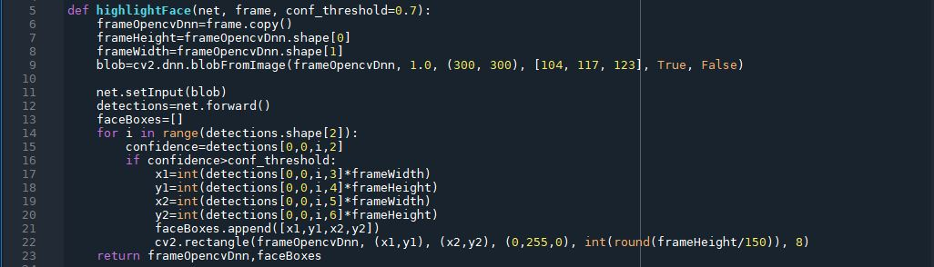

**V.3. Detect the face**

In computer vision, one essential problem we are trying to figure out is to automatically detect objects in an image without human intervention. Face detection can be thought of as such a problem where we detect human faces in an image.

There may be slight differences in the faces of humans but overall, it is safe to say that there are certain features that are associated with all the human faces. There are various face detection algorithms but Viola-Jones Algorithm is one of the oldest methods that is also used today and we will use the same later in the article. You can go through the Viola-Jones Algorithm after completing this article as I’ll link it at the end of this article.

Face detection is usually the first step towards many face-related technologies, such as face recognition or verification. However, face detection can have very useful applications. The most successful application of face detection would probably be photo taking. When you take a photo of your friends, the face detection algorithm built into your digital camera detects where the faces are and adjusts the focus accordingly.

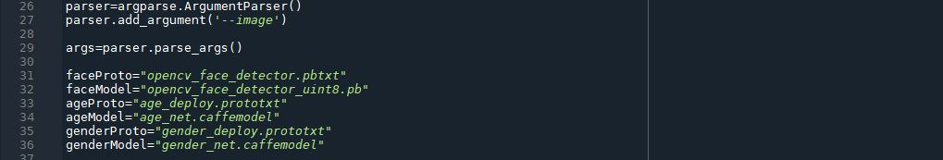

**V.4. Calculate the face value & gender**

Initialize the mean values for the model and the lists of age ranges and genders to classify from.

**4.JPG**

**V.5. Implementing our OpenCV age & gender detector**

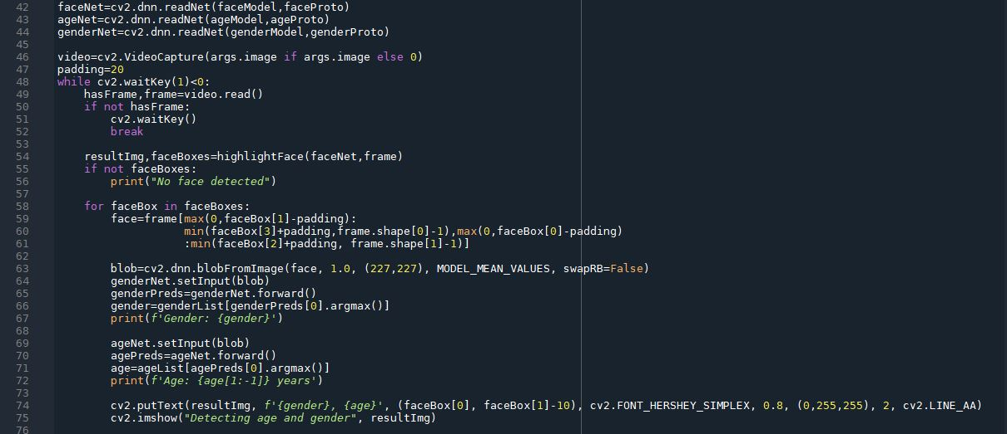

**VI. Gender and Age Detection – About the Project**

In this Python Project, we will use Deep Learning to accurately identify the gender and age of a person from a single image of a face. We will use the models trained by [Tal Hassner and Gil Levi](https://talhassner.github.io/home/projects/Adience/Adience-data.html). The predicted gender may be one of ‘Male’ and ‘Female’, and the predicted age may be one of the following ranges- (0 – 2), (4 – 6), (8 – 12), (15 – 20), (21 – 24), (25 – 32), (38 – 43), (48 – 53), (60 – 100) (9 nodes in the final softmax layer). It is very difficult to accurately guess an exact age from a single image because of factors like makeup, lighting, obstructions, and facial expressions. And so, we make this a classification problem instead of making it one of regression.

* Detect faces
* Classify into Male/Female
* Classify into one of the 8 age ranges
* Put the results on the image and display it

**VII. RESULTS**

**\*Capturing the facial data and giving the proper output**

**Fig. 1(output)**

**Fig. 1**

**Fig. 2(output)**

**Fig. 2**

**VIII. CONCLUSION**

In this work, it is been concluded that detection of age and gender take consideration of research few years ago. In this work, technique of morphological and SIFT is applied to search key features from the images. The key features of the images are the color and texture of the image. The simulation results shows that proposed algorithm performed well in terms of fault detection rate and accuracy. In future, further improvement will be done in proposed work for iris reorganization for batter reorganization.

**IX. REFERENCES**

[1]. A. Kumar and F. Shaik,” Importance of Image Processing”, 2016

[2]. Chenjing Yan, Congyan Lang, Tao Wang, Xuetao Du, and Chen Zhang,” Age Estimation Based on

Convolutional Neural Network”, 2014 Springer International Publishing Switzerland

[3]. Aditya K. Saxena, Shweta Sharma and Vijay K. Chaurasiya,” Neural Network based Human Age-group

Estimation in Curvelet Domain”, 2015 The Authors Published by Elsevier B.V.

[4]. Dong Yi (B), Zhen Lei, and Stan Z. Li,” Age Estimation by Multi-scale Convolutional Network”, 2015

Springer International Publishing Switzerland

[5]. A. Ultsch, G. Guimaraes, D. Korus, H. Li,” Knowledge Extraction from Artificial Neural Networks and

Applications”, 1993 Springer

[6]. Eran Eidinger, Roee Enbar, and Tal Hassner,” Age and Gender Estimation of Unfiltered Faces”, 2014 IEEE

[7]. Yunjo Lee, Cheryl L. Grady, Claudine Habak, Hugh R. Wilson, and Morris Moscovitch,” Face Processing

Changes in Normal Aging Revealed by fMRI Adaptation”, 2011 Massachusetts Institute of Technology

[8]. R. Begg1 and J. Kamruzzaman,” Neural networks for detection and classification of walking pattern changes

due to ageing”, 2006 ACPSEM/EA

[9]. Hang Qi and Liqing Zhang,” Age Classification System with ICA Based Local Facial Features”, 2009

Springer-Verlag Berlin Heidelberg

[10]. Kensuke Mitsukura, Yasue Mitsukura, Minoru Fukumi, and Sigeru Omatu,” An Age Estimation System

Using the Neural Network”, 2003 Springer-Verlag Berlin Heidelberg

[11]. Chao Yin and Xin Geng,” Facial Age Estimation by Conditional Probability Neural Network”, 2012 Springer-

Verlag Berlin Heidelberg

[12]. Sarah N. Kohail,” Using Artificial Neural Network for Human Age Estimation Based on Facial Images”, 2012

International Conference on Innovations in Information Technology

Website:

* https://quick-adviser.com/
* <https://data-flair.training/>
* <https://towardsdatascience.com/>
* <https://learnopencv.com/>
* https://www.ris-ai.com/